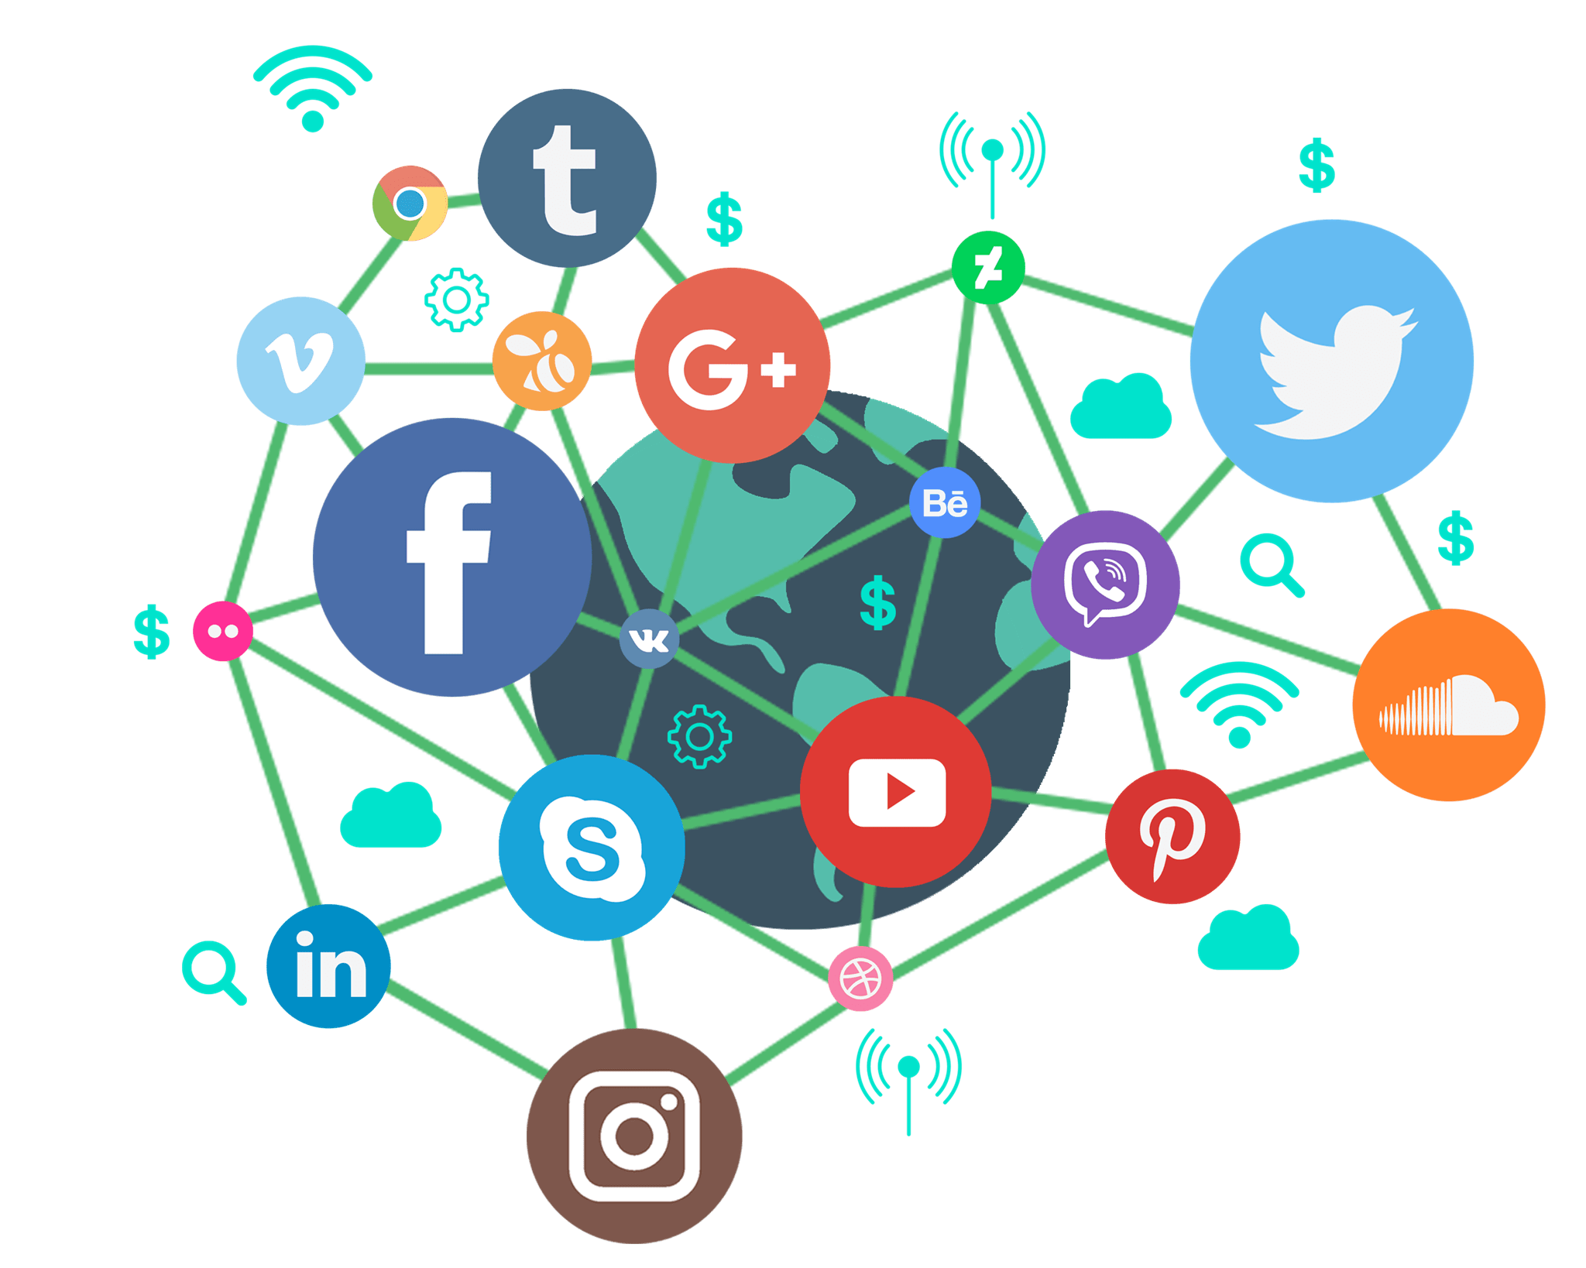A social media, according to Merriam-Webster (2021), is an internet platform hosted by a private company that allows users/customers to join in order to communicate with friends, express ideas, share multimedia, and join online communities. Because of their involvement in both personal and private life, social media as a technology features many choices, opportunities, and risks. The choices afforded by social media includes data, targeted advertising, and free communication. Social media companies have the ability to make their platform an opportunity for . Platforms also have a lot of power, which brings the risk of privacy, production loss and even vigilantism.

The choices a social media company/platform can have requires a careful balancing act of need and want. One choice a social media company has is data. Data is to social media like butter is to bread. Without data a social media cannot bloom full of users and communities, but, how much data should a social media company have? It’s easy to say they should only keep important user data like name, age, and email address but there is other data such a user posts, multimedia, friends, groups, posts they liked, links they’ve clicked, number of followers, previous internet activity, etc. Another choice data gives is how to store and display this data. On the computers of users in fragmented chunks, privately owned servers, amazon web services servers, or multiple servers around the world. When displaying data should images and videos be shown one by one, in collages, with text, should edges be rounded, should they expand when the mouse hovers over them? With data, there are many small choices that ultimately build up to a platforms entire design methodology and mission statement. Another choice afforded by social media is targeted advertising. Targeted advertising relies on tracking user activity and then displaying advertisements for products or services that relate to said activity.